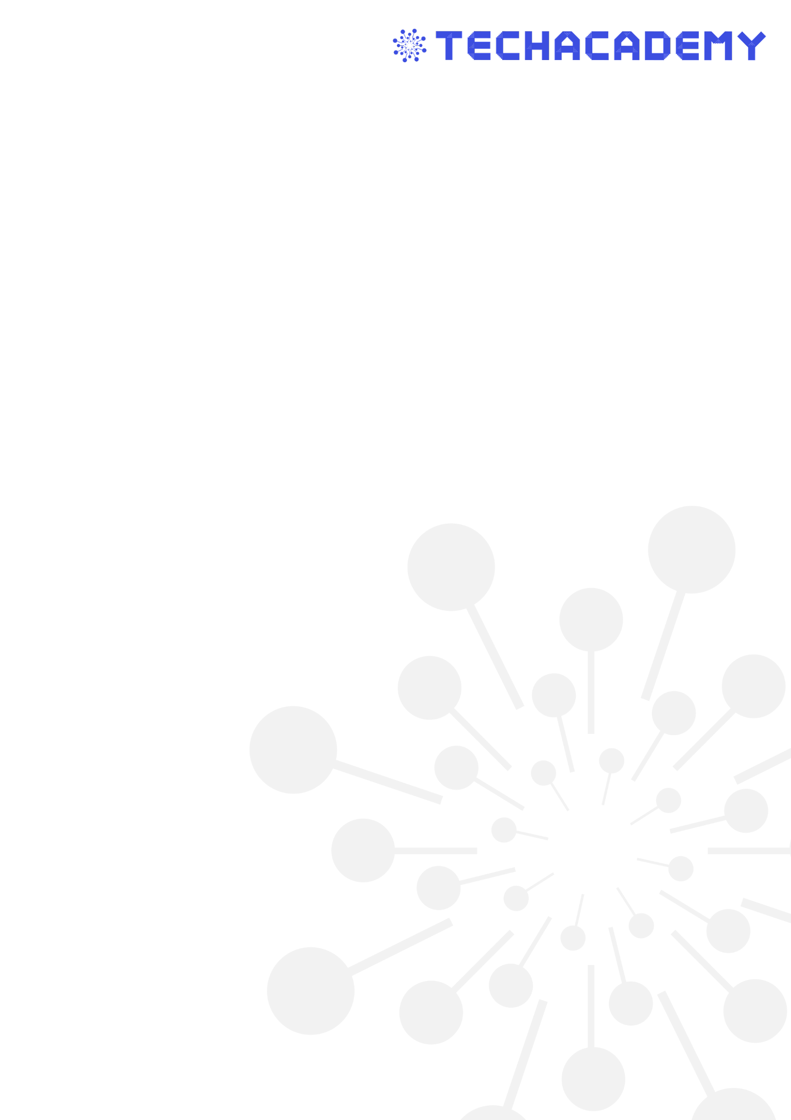**Max Mustermann**

successfully participated in the program

**Web Development**

with TechAcademy e.V. at Goethe University Frankfurt in the summer semester 2021. The program dealt with the following subjects:

* ein
* kurs
* und
* noch
* einer
* und
* noch
* einer

In addition, as part of a group effort, a functional quiz app was designed and successfully programmed from scratch. In this app, content was inserted dynamically using JavaScript, navigation between questions was done with JavaScript, and a counting system was integrated.

Max also took part in workshops with the following companies:

* DuckDuckGo
* Celonis
* xyz

__________________________ __________________________

**Natnael Fekade** **Georgios Brussas**

**Chairman of the board Co-Chairman of the board**

**Frankfurt, 22.08.2021**

**About TechAcademy e.V.**

TechAcademy e.V. is a student initiative at Goethe University Frankfurt training the next digital leaders. Students of any discipline get the opportunity to acquire coding skills in Data Science and Web Development programs. Students apply their acquired tech skills in projects, solving real-world problems digitally.

In addition to regular coding meetups, TechAcademy actively supports students in developing and implementing their projects through workshops, lectures, and company visits. In this way, participants gain practical experience in the tech sector while still studying and establish contact with relevant companies. In addition, TechAcademy organizes the annual TechConference — a digitization conference with high-ranking speakers from business, politics and science.

For this voluntary engagement TechAcademy won the national award “Students of the Year 2021”, awarded jointly by the German National Association for Student Affairs (Deutsches Studentenwerk) and the German Association of University Professors and Lecturers (Deutscher Hochschulverband).